Sharpsville Elementary Winter Read-A-Thon

The Sharpsville Elementary Winter Read-A-Thon is in full swing! Thank you for your contributions and for continuing to spread the word! You and your student can reach out electronically by email, Facebook, Twitter, and any other social media platform. Additionally, donors can make a contribution to support your child with a simple and secure online transaction. Donations may also be made by check (checks may be payable to: Sharpsville Area School District.).
Simply share your child’s link and/or the link below so you and others can make a flat donation.
https://99pledges.com/fund/sharpsville
Sharpsville Elementary Winter Read-A-Thon

The Sharpsville Elementary Winter Read-A-Thon is in full swing! Thank you for your contributions and for continuing to spread the word! You and your student can reach out electronically by email, Facebook, Twitter, and any other social media platform. Additionally, donors can make a contribution to support your child with a simple and secure online transaction. Donations may also be made by check (checks may be payable to: Sharpsville Area School District.).
Simply share your child’s link and/or the link below so you and others can make a flat donation.
https://99pledges.com/fund/sharpsville
Looking for Holiday Gift Ideas?

How about making a donation to the Sharpsville Elementary Winter Read-A-Thon in the gift recipient’s name? Simply visit your child’s link and/or the link below so you and others can make a flat donation.
https://99pledges.com/fund/sharpsville
Gift tags may be downloaded at www.sharpsville.k12.pa.us. Sample images are below.
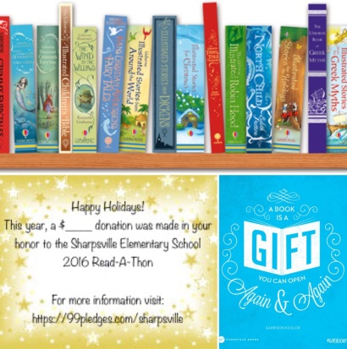
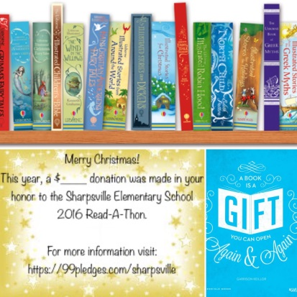

Looking for Holiday Gift Ideas?

How about making a donation to the Sharpsville Elementary Winter Read-A-Thon in the gift recipient’s name? Simply visit your child’s link and/or the link below so you and others can make a flat donation.
https://99pledges.com/fund/sharpsville
Gift tags may be downloaded at www.sharpsville.k12.pa.us. Sample images are below.
